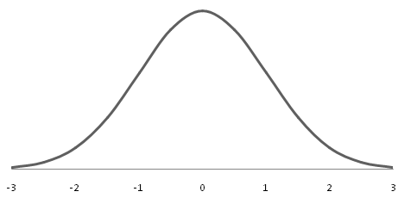

-1,28

Z = -2,63

Reject H0